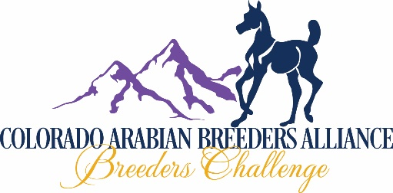
FUTURITY IN UTERO NOMINATION YEAR 2021-COMPETITION YEAR 2022
2021 BREEDING (IN UTERO) FOR 2022 FOAL AND 2022 WEANLING COMPETITION

NOMINATION PERIOD: SEPTEMBER 1, 2021 TO AUGUST 1, 2022
ONE NOMINATION PER FORM
PUREBRED: CHECK HERE [__] HALF ARABIAN: CHECK HERE [__]
NOMINATION FEE $50: CHECK HERE [__]

PLEASE COMPLETE THE IN UTERO NOMINATED FOAL REPORT WHEN YOUR FOAL IS BORN!

IF THIS IS A NOMINATION TRANSFER AS A RESULT OF NO LIVE FOAL FROM 2020 BREEDING: CHECK HERE [__] AND ATTACH THE IN UTERO NOMINATED FOAL REPORT FOR 2021 (MAIL TO DEBBIE HELMICK: NO ADDITIONAL FEE)

SIRE: | REGISTRATION# | BREED:
DAM: | REGISTRATION# | BREED:

NAME OF FOAL OWNER: ________________________________________________________________________
ADDRESS: ____________________________________________________________________________
CITY: _______________________________________ STATE: ______________ ZIP: ____________
PHONE: _____________________ EMAIL: ________________________________________________
FARM OR RANCH NAME: ________________________________________________________________________
WEB SITE: _____________________________________________________________________________________

NAME OF BREEDER (if Different): __________________________________________________________________
ADDRESS: ____________________________________________________________________________
CITY: _______________________________________ STATE: ______________ ZIP: ____________
PHONE: _____________________ EMAIL: ________________________________________________
FARM/RANCH NAME: __________________________________WEB SITE: ________________________________

I, THE UNDERSIGNED, HAVE READ, UNDERSTAND, AND AGREE TO ABIDE BY, THE COLORADO ARABIAN BREEDERS ALLIANCE (CABA) CBC FUTURITY RULES AND REGULATIONS, AND THAT ALL ENTRIES MADE ON THIS FORM ARE TRUE AND CORRECT.
X_________________________________________________________________DATE_______________________
(OWNER OR AGENT SIGNATURE)
MAKE CHECKS PAYABLE TO COLORADO ARABIAN BREEDERS ALLIANCE (CABA)
SEND YOUR NOMINATION (WITH ALL FEES) TO: CABA NOMINATIONS
C/O DEBBIE HELMICK
930 W WOLFENSBERGER RD
CASTLE ROCK, CO 80109
CREDIT CARDS ACCEPTED (4% SURCHARGE): (AMERICAN EXPRESS-DISCOVER-MASTERCARD-VISA)
NAME AS IT APPEARS ON CARD __________________________________________________________
C/C# _________________________________________________ BILLING STREET# ________________
EXP DATE __________/__________ SECURITY CODE __________ BILLING ZIP _____________________

X____________________________________________________ DATE: _______/_______/_______ (CARD HOLDER SIGNATURE)
YOU MAY EMAIL THIS FORM TO wildflower_farms@mindspring.com IF USING C/C

